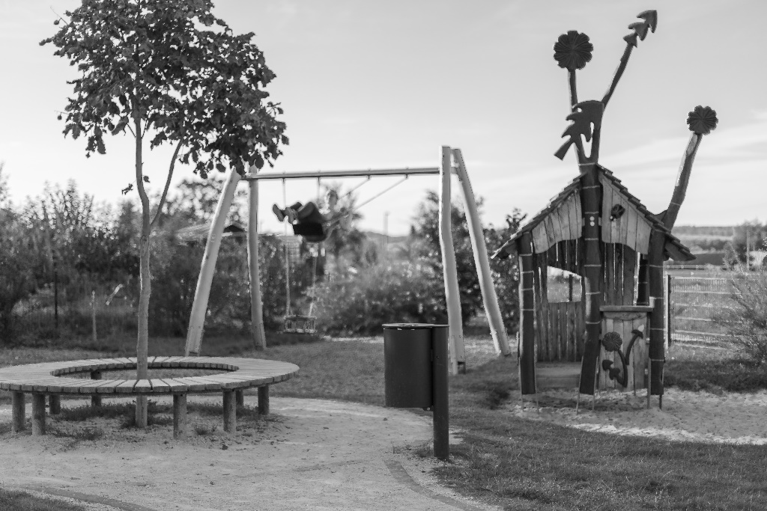 50mm, f1,4, 1/2000s
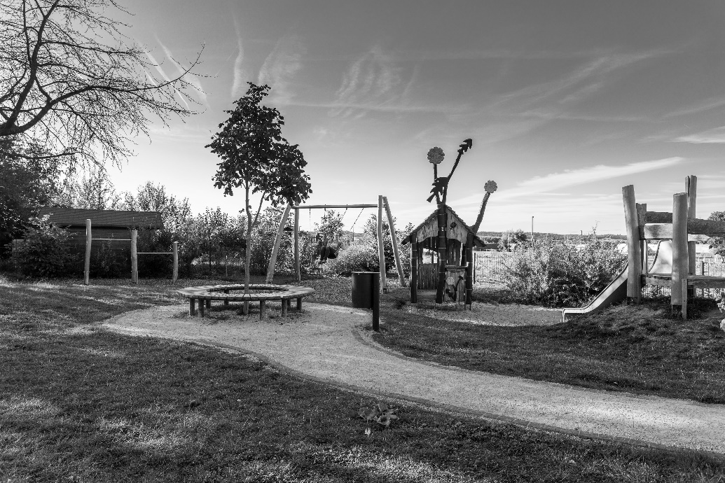 25mm, f 7,1, 1/125s
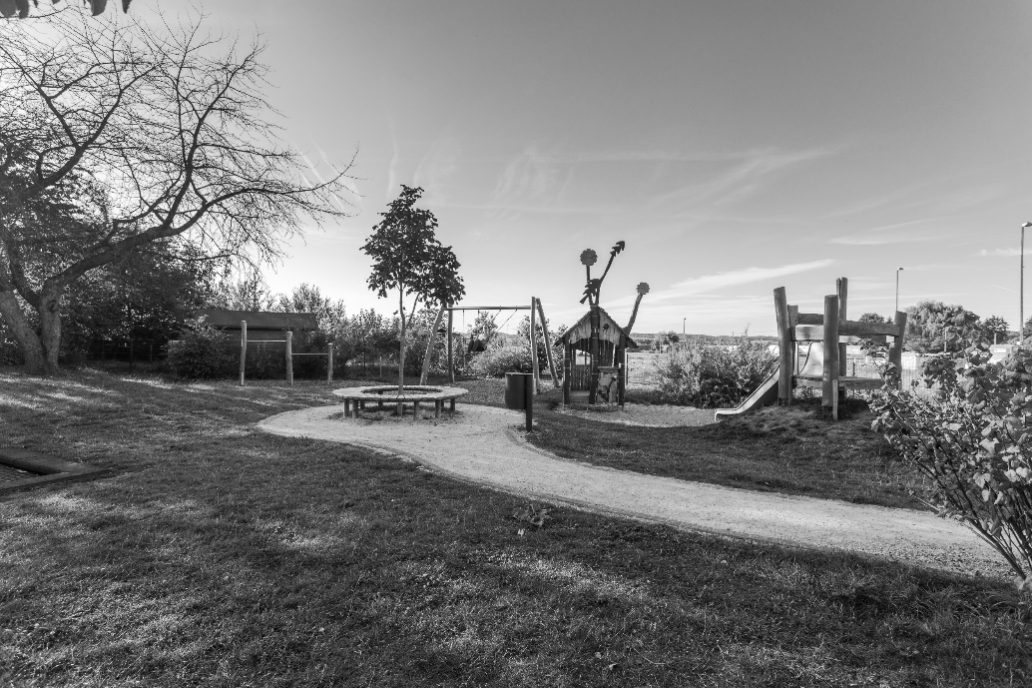 17mm, f7,1, 1/125s
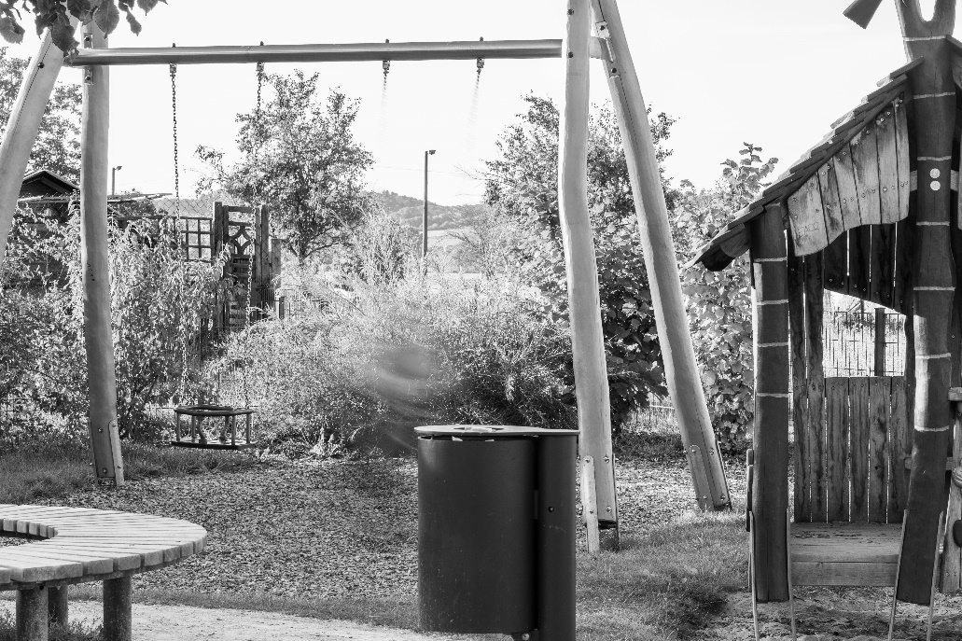 105mm, f20,1/6s,
350mm, f4, 1/125s
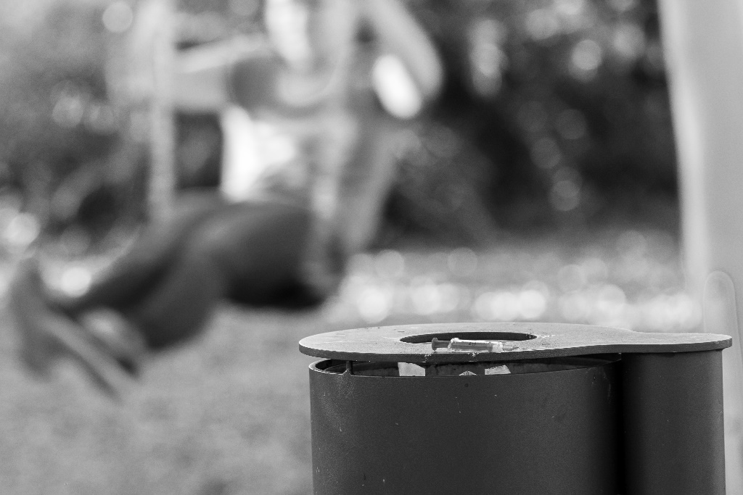 350mm, f4, 1/90s

