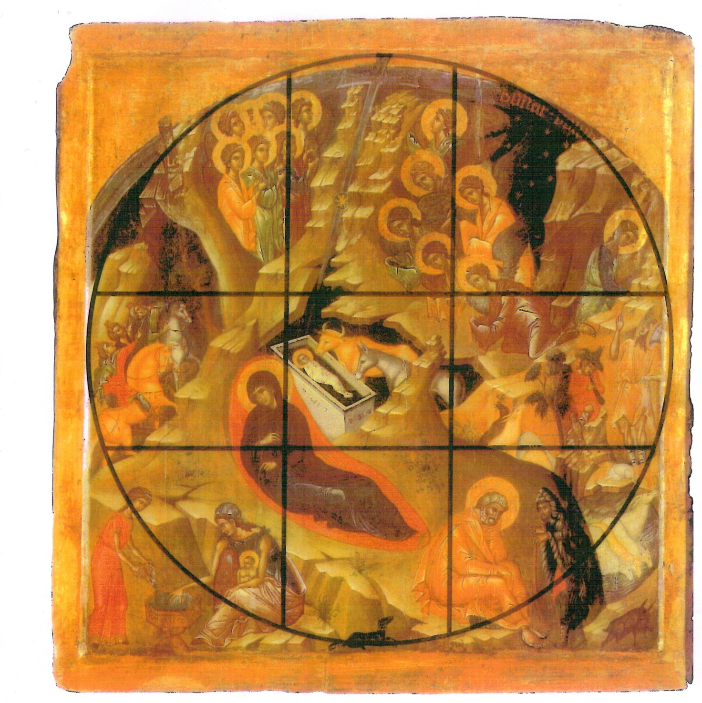aus: Proud, Linda: Icons, A Sacred Art, The Pitkin Guide, Great Britain, Pitkin Publishing Ltd, reprint 2007, S. 19.

